

Individual Project:

ENGD3000

Interim Report

***Module tutor: Dr Seng Chong***

***Student – Samuel Towner***

***P Number – P2448117***

Contents

Abstract: 3

Overall aim and objectives: 3

Project aim: 3

Objectives: 3

Background research: 3

Existing products: 3

Available software choices: 4

Available hardware choices: 4

Progress thus far: 4

Current project choices: 4

Flowchart 1 5

WBS 1 5

Plan for the next stage of the project: 5

Next steps: 5

Bibliography 7

# Abstract:

The following is an interim report on the design and development of an IoT enabled system that takes orders straight from the customer to the kitchen, before an included robot transports the food from the kitchen to the required table. This lowers contact between customers and employees while also speeding up order times.

# Overall aim and objectives:

## Project aim:

To design and develop an IoT enabled system that creates a more efficient restaurant pipeline from ordering to receiving food, while reducing contact between customer and staff.

## Objectives:

1. Create a list of hardware and software that will be used within the project.
2. Design and develop a product capable of using a tablet device to take an order directly from the customer and send it over an IoT network.
3. Design and develop a product capable of displaying incoming orders to the kitchen staff.
4. Design and develop a robot capable of transporting orders from kitchen to table while mapping and manoeuvring around the restaurant.
5. Have all project components work together/communicate over an IoT network.

# Background research:

## Existing products:

Background research began with looking into existing products that have a similar function. The following list is a collection of online sources that are covering the use of robots within restaurant settings:

* <https://www.scotsman.com/news/people/scotlands-first-robot-waiters-are-being-rolled-out-restaurant-1408446> [1]
* <https://www.bbc.co.uk/news/av/world-asia-30460737> [2]
* <https://www.youtube.com/watch?v=kvzrP2lrvqA&ab_channel=Vocativ> [3]
* <https://www.latimes.com/world-nation/story/2020-05-31/hello-and-welcome-robot-waiters-to-the-rescue-amid-virus> [4]
* <https://www.youtube.com/watch?v=PJ_47fj4aF8&feature=emb_title&ab_channel=ServiceRobots> [5]
* <https://www.youtube.com/watch?v=SkWbNcGEJVc&ab_channel=ynuk.tv> [6]
* <https://www.techinasia.com/singapore-restaurant-autonomous-drone-waiters> [7]
* <https://www.straitstimes.com/lifestyle/food/robot-lucy-at-your-service-at-newly-opened-rong-heng-seafood> [8]

Over the years it seems the most common designs are based on humans with their arms holding a double layer of trays. Some seem to follow specific routes designated by painted lines on the floor, others seem to map and manoeuvre with sensors such as LiDAR.

## Available software choices:

Next, I researched what software to use as the framework for the whole system. I began by contacting friends who have experience within robotics programming. Their suggestions consisted of looking into the software CoppeliaSim [9] and ROS [10].

Looking into both suggestions it seems that CoppeliaSim can use ROS within its architecture alongside other control options, these can be written in a collection of programming languages.

## Available hardware choices:

Alongside the software I will also need to choose what hardware is being used within the project. With the required tasks in hand I found the following hardware options to be valid choices: Arduino, Raspberry Pi and the Nvidia Jetson Nano 2GB.

# Progress thus far:

## Current project choices:

After the mentioned research I had to make multiple choices on what I will be testing first. These include choosing the software and hardware I will be using to develop my idea.

Once broken down (As seen in the Work Breakdown Structure) I decided the project would have its framework based on ROS as it’s Node based functionality will allow for modularity within the project. With that in mind I also decided to include the use of all three mentioned hardware components. The reason for this decision was that each has its strengths and areas it excels in so with all in use all bases should be covered.

The following is a sketch of each component of the pipeline:

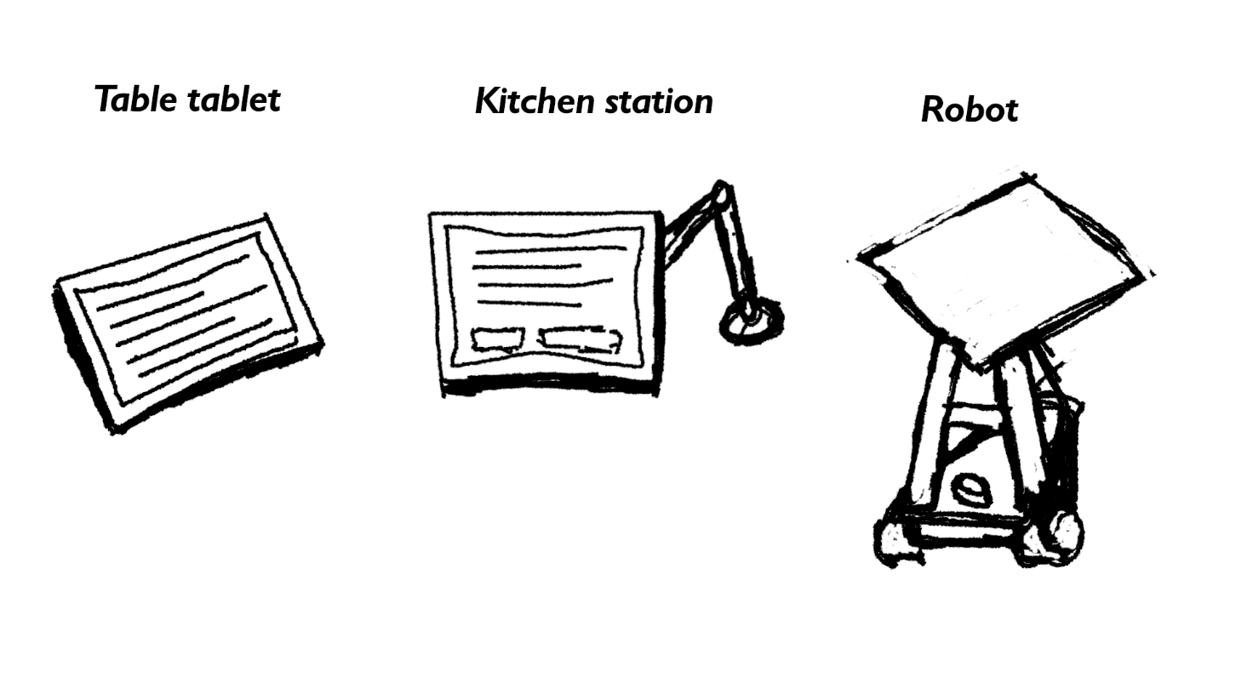

The Table tablet will have a simple UI where the customer can order. The kitchen station will allow for accepting and setting orders as outgoing for the robot while the robot will have two main drive motors, LiDAR for mapping and a tray atop its build.

I have also setup a Trello board [11] which should help keep all the ‘To dos’ in a single place allowing for easier management.

Since I cannot continue physical testing until I have received all hardware, I created a flow chart of information within the system and a work breakdown structure as to better visualise the work needing to be done, both are seen below:

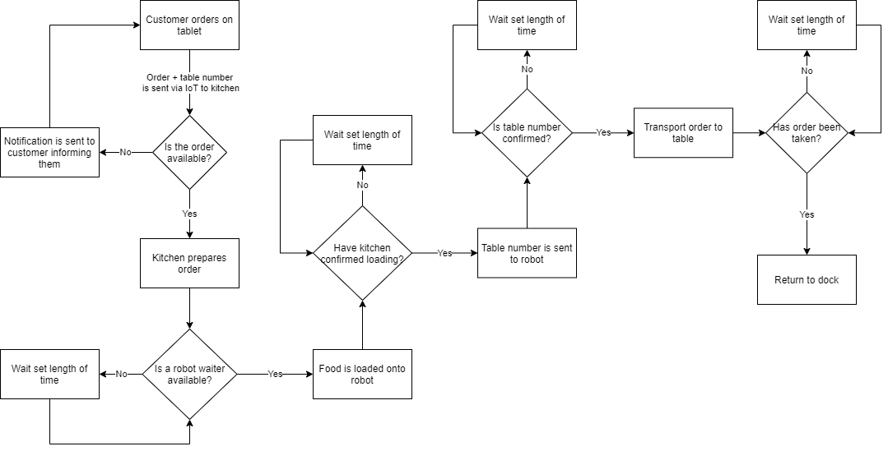

### Flowchart 1

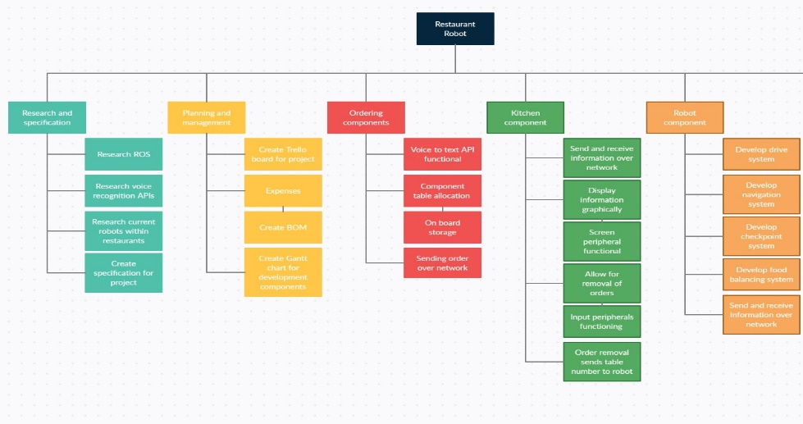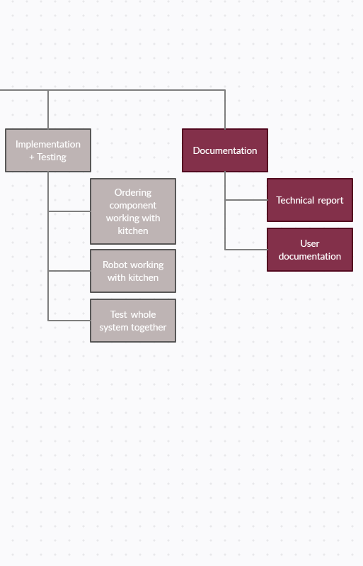

### WBS 1

# Plan for the next stage of the project:

## Next steps:

As I wait for hardware to arrive, I am looking into ROS and how its node system works. In continuing to do so I will be in the best possible position for when I receive the ordered hardware as I will be able to get straight into the testing and development of the system.

Once I have a better understanding of ROS development, I will produce a Gantt chart to help keep the project moving as expected.

As my testing continues a risk assessment will also be produced based on any possible dangers found within the project’s tests.

# Bibliography

|  |  |
| --- | --- |
| [1] | A. Howarth, “Scotland's first robot waiters are being rolled out in a restaurant,” 5th September 2019. [Online]. Available: https://www.scotsman.com/news/people/scotlands-first-robot-waiters-are-being-rolled-out-restaurant-1408446. [Accessed 19th December 2020]. |
| [2] | T. Allman, “China restaurant introduces robot waiters - BBC News,” BBC, 13th December 2014. [Online]. Available: https://www.bbc.co.uk/news/av/world-asia-30460737. [Accessed 19th December 2020]. |
| [3] | Vocativ, “Robots Are The Waiters At This Restaurant - Youtube,” Vocativ, 6th March 2017. [Online]. Available: https://www.youtube.com/watch?v=kvzrP2lrvqA&ab_channel=Vocativ. [Accessed 19th December 2020]. |
| [4] | A. Press, “Robot waiters lend a hand amid coronavirus outbreak - Los Angeles Times,” 29th May 2020. [Online]. Available: https://www.latimes.com/world-nation/story/2020-05-31/hello-and-welcome-robot-waiters-to-the-rescue-amid-virus. [Accessed 19th December 2020]. |
| [5] | S. Robots, “Amy Waitress Robot - Youtube,” 2nd September 2019. [Online]. Available: https://www.youtube.com/watch?v=PJ_47fj4aF8&feature=emb_title&ab_channel=ServiceRobots. [Accessed 19th December 2020]. |
| [6] | ynuk.tv, “Robot Waitress First in UK to Server Customers - Youtube,” 18th August 2019. [Online]. Available: https://www.youtube.com/watch?v=SkWbNcGEJVc&ab_channel=ynuk.tv. [Accessed 19th December 2020]. |
| [7] | S. Millward, “Singapore restaurant shows off autonomous drone waiters,” TechInAsia, 10th February 2015. [Online]. Available: https://www.techinasia.com/singapore-restaurant-autonomous-drone-waiters. [Accessed 19th December 2020]. |
| [8] | B. Ang, “Robot Lucy at your service at newly opened Rong Heng Seafood,” The Straits Times, 7th February 2016. [Online]. Available: https://www.straitstimes.com/lifestyle/food/robot-lucy-at-your-service-at-newly-opened-rong-heng-seafood. [Accessed 19th December 2020]. |
| [9] | “Robot simulator CoppeliaSim: create, compose, simulate, any robot - Coppelia Robotics,” Coppelia Robotics, [Online]. Available: https://www.coppeliarobotics.com/. [Accessed 19th December 2020]. |
| [10] | “Documentation - ROS Wiki,” Open Robotics, [Online]. Available: http://wiki.ros.org/. [Accessed 19th December 2020]. |
| [11] | “Trello,” Atlassian, [Online]. Available: https://trello.com/. [Accessed 19th December 2020]. |